Write a program to pronounce list of names using win32 API. If you are given a list l as follows:
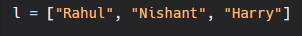
Your program should pronouce:
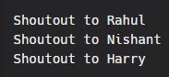
Note: If you are not using windows, try to figure out how to do the same thing using some other package

